**TOURISM PLACES**



A

Human Computer Interface Course Project Report

in partial fulfilment of the degree

**Bachelor of Technology**

in

**Computer Science & Engineering**

**By**

B. Harshitha 2103A51005

Ch. Pujitha 2103A51007

P. Rohini 2103A51029

N. Sathwika 2103A21027

Under the guidance of

**Mr. K. RAVI CHYTHANYA**

Assistant Professor, School of Computer Science and AI

**Submitted to**

**School of Computer Science and Artificial Intelligence**





**DEPARTMENT OFCOMPUTERSCIENCE& ENGINEERING**

**CERTIFICATE**

This is to certify that the **Human Computer Interface - Course Project** Report entitled **“ TOURISM PLACES ”** is a record of bonafide work carried out by the students Harshitha, Pujitha, Rohini, Sathwika bearing Roll No(s) 2103A51005, 2103A51007, 2103A51029, 2103A51027 during the academic year 2022-2023 in partial fulfillment of the award of the degree of ***Bachelor of Technology*** in **Computer Science & Engineering** by the SR University, Warangal.

**Lab In-charge Head ofthe Department**

## TABLE OF CONTENTS:

TITLE Page no

Abstract 1

Objective 2

Implementation Code 3-99

Result Screens 99-1

Conclusion 109

**ABSTRACT :**

Tourism became a common topic while the level of tourist requirements increased dramatically. Generally traditional travel websites provided general information or price list of hotel, transport tickets, etc. These kinds of information cannot satisfy travelers any more. Destination choices available to consumers have been increased rapidly by number.

Today’s tourism marketers must influence consumer decision making in an increasingly complex and competitive global market place. Tourism is a complicated setting involving a diverse group of active stakeholders where each person has different interests in the tourism market. It is essential that a consistent approach is used by all tourism stakeholders operating within a single destination. A challenge for travel websites is to present creative and special travel plans to attract the users.

It focuses mainly on content because it is seen as the key factor associated with an effective website. In order to achieve this target, relying on software reuse and abstraction techniques, this project demonstrates a new system, aiming to generate creative travel plans. The main aim of this project is to develop software for Tourists.

The design and implementation of a tourism places platform is developed, that will assist tourists in gaining access to information on tourist locations. We also did a survey where we found the interest of people for travels.

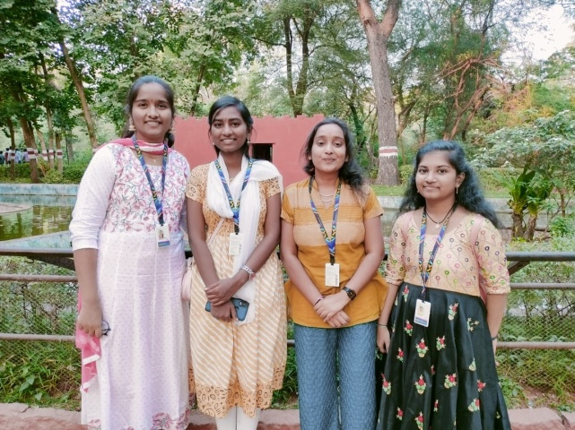 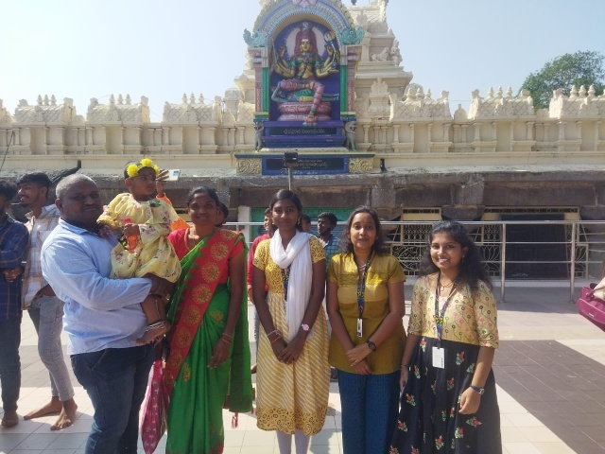

.In this project, we tried to create a tourist website which will be easy to use by following the various principles of Human Computer Interface. This project has been developed to help the tourists quickly which is easy to use interface. This project is developed using HTML, CSS and Java script languages. Creating and managing requirements is a challenge of IT, systems and product development projects or indeed for any activity where you have to manage a contractual relationship.

**OBJECTIVE :**

The objective of the project is to develop a system that automates the processes and activities of a travel and access the information of the location. The purpose is to design a system which one can perform all operations related to travelling.

The system allows one to easily access the relevant information. Users can decide about places they want to visit. The tourism places management system allows the user of the system access all the details such as weather, location, events, etc.

The main purpose is to help tourism companies to manage customer and hotels etc. This system can also be used for both professional and business trips.

This system also provides the directions of the location which they want to visit.

**DEFINITIONS OF THE ELEMENTS USED IN THE PROJECT:**

1 . HTML

* HTML stands for Hyper Text Markup Language.
* It is the standard markup language for creating Web pages.
* It describes the structure of a Web page.
* It consists of a series of elements.
* It elements tell the browser how to display the content.
* It’s elements label pieces of content such as "this is a heading", "this is a paragraph", "this is a link", etc.

2 . CSS

* CSS stands for Cascading Style Sheets.
* It describes how HTML elements are to be displayed on screen, paper, or in other media.
* It saves a lot of work and it can control the layout of multiple web pages all at once.
* External style sheets are stored in CSS files.

3 . JAVASCRIPT

* JavaScript is a lightweight, cross-platform, and interpreted compiled programming language which is also known as the scripting language for web pages.
* It is well-known for the development of web pages, many non-browser environments also use it.
* JavaScript on a webpage may not read/write arbitrary files on the hard disk, copy them or execute programs. It has no direct access to OS functions.

**DESIGN :**

Screen-1:

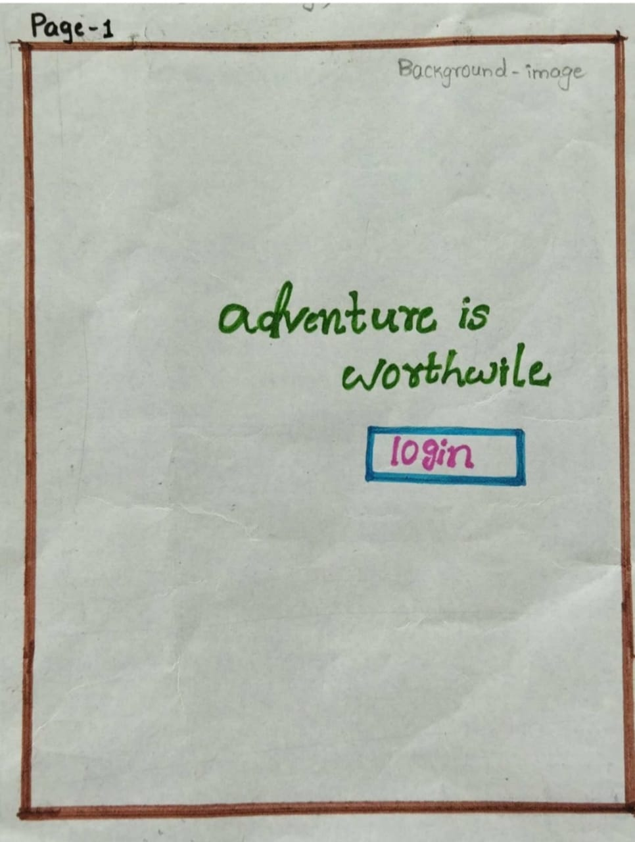

Screen-2:

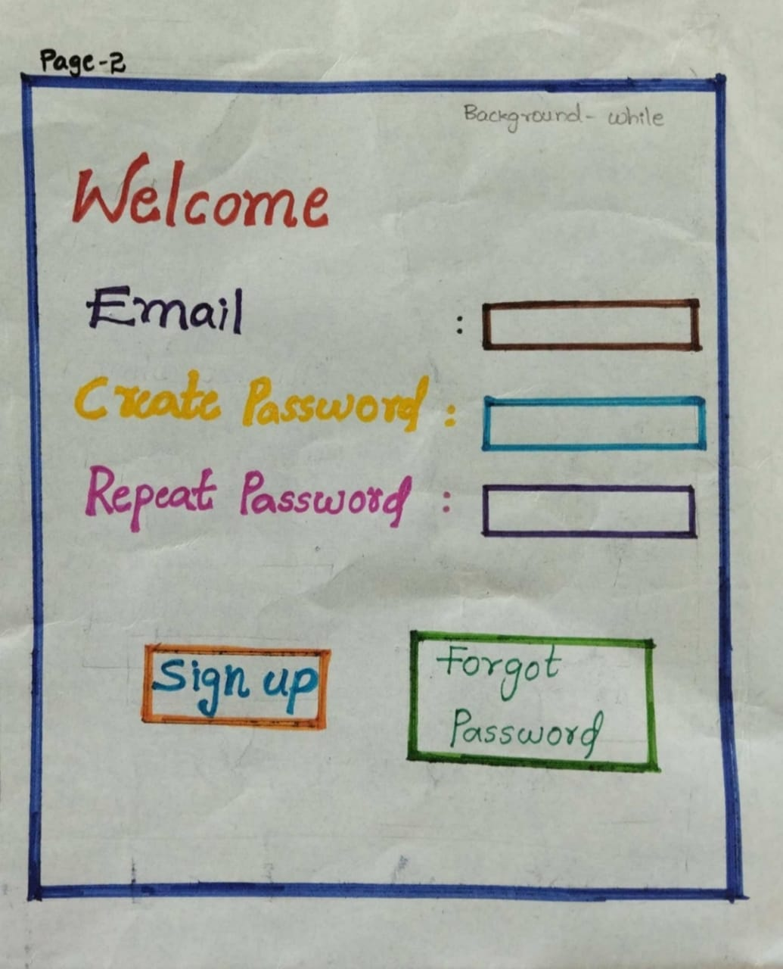

Screen-3:

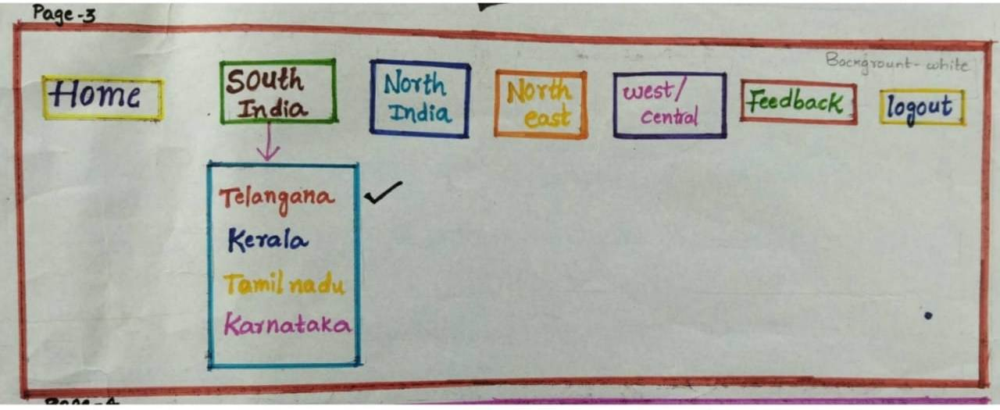

Screen-4:

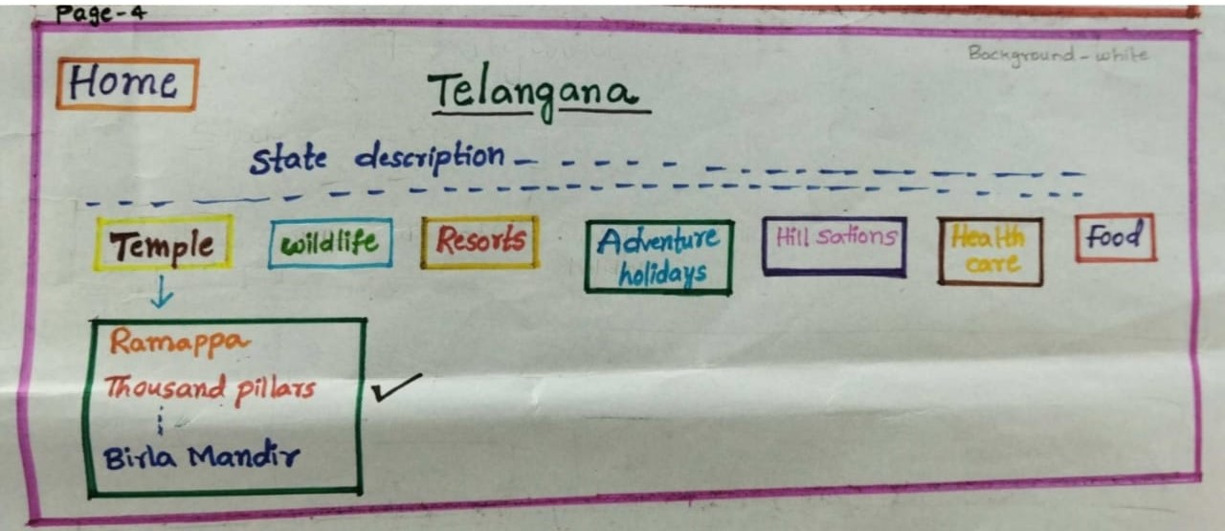

Screen-5:

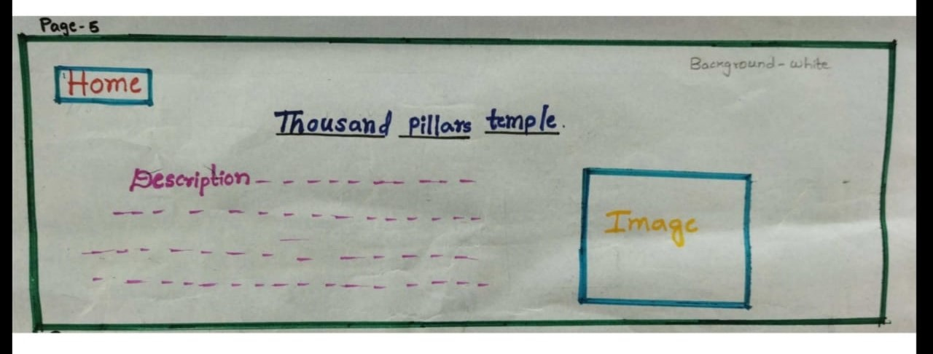

Screen-6:

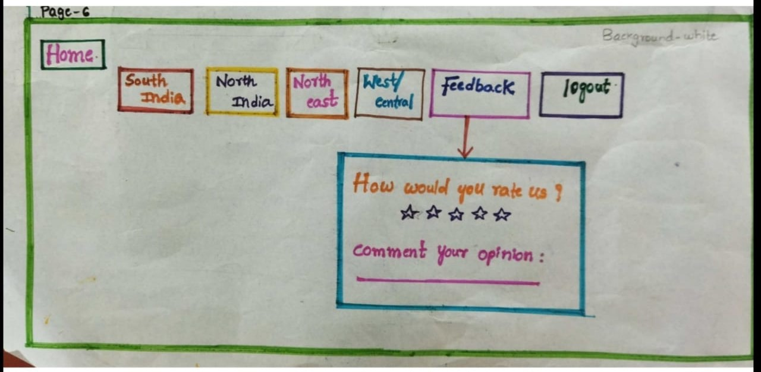

Screen-7:

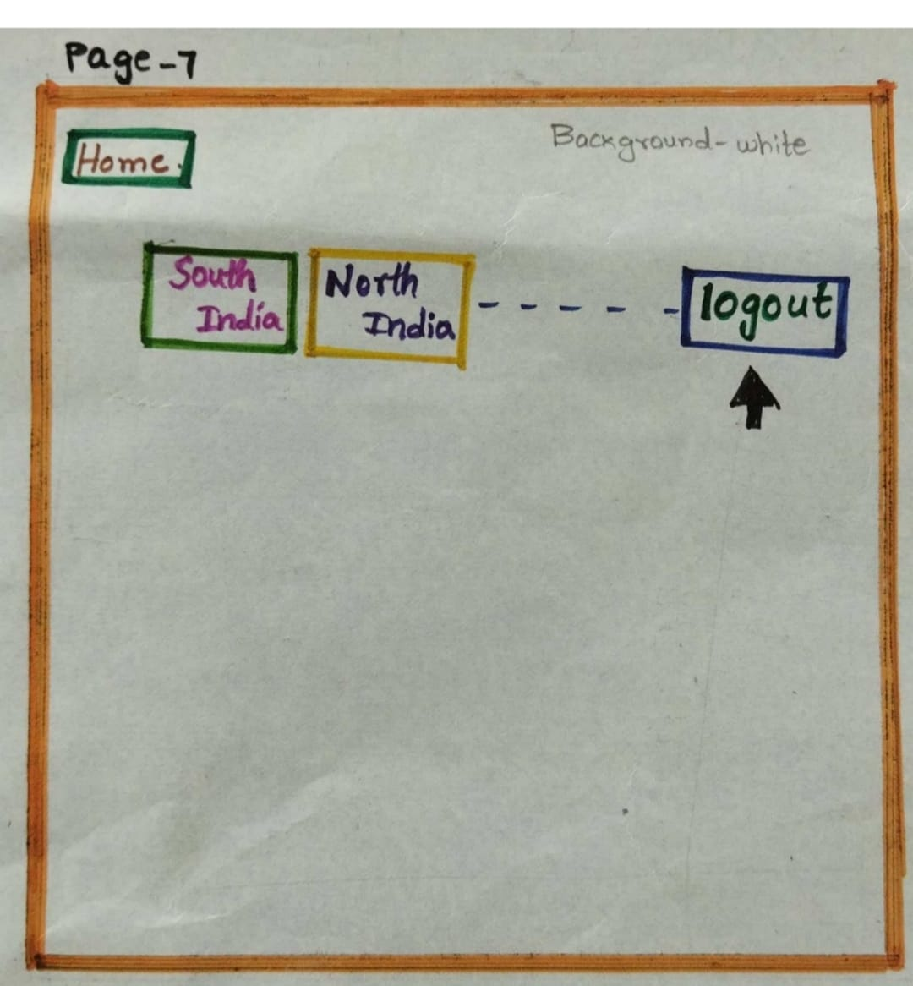

Screen-8:

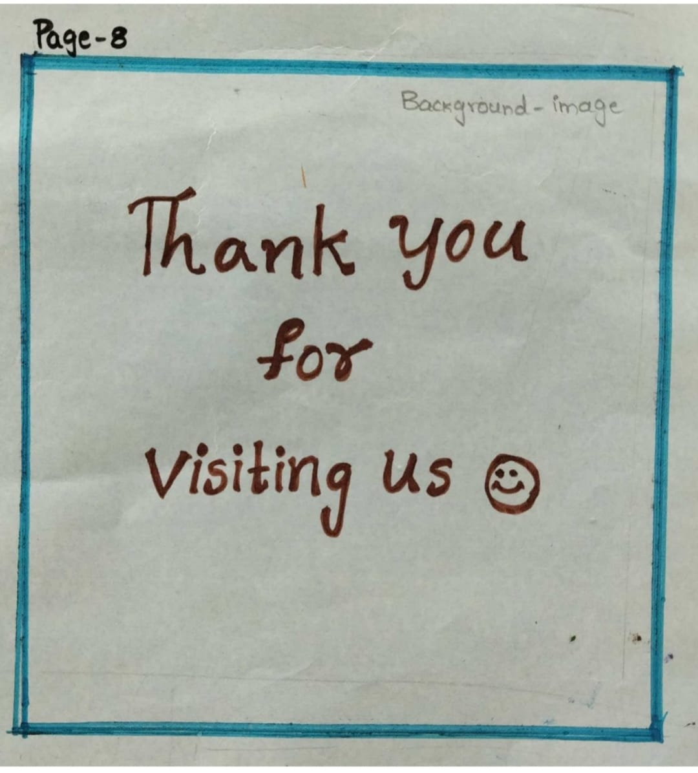

**IMPLEMENTATION OF CODE:**

**//Main page**

<html>

<head>

<meta name="viewport"

content="width=device-width,

intial-scale=1">

<link rel="preconnect" href="https://fonts.googleapis.com">

<link rel="preconnect" href="https://fonts.gstatic.com" crossorigin>

<link href="https://fonts.googleapis.com/css2?family=Josefin+Sans&family=Shalimar&display=swap" rel="stylesheet">

<link rel="preconnect" href="https://fonts.googleapis.com">

<link rel="preconnect" href="https://fonts.gstatic.com" crossorigin>

<link href="https://fonts.googleapis.com/css2?family=Arapey&family=Bebas+Neue&family=Cinzel:wght@500&family=Dancing+Script:wght@700&family=Fredoka+One&family=Lato:ital@0;1&family=Lora:ital,wght@1,700&family=Montserrat&family=Open+Sans&family=Roboto+Serif:ital,opsz,wght@0,8..144,400;1,8..144,200&family=Teko:wght@500&display=swap" rel="stylesheet">

</head>

<style>

body

{

text-align:center;

background-image:url("main.jpg");

background-repeat: no-repeat;

background-size: 1300px 600px;

}

h1{

font-family: 'Cinzel', serif;

color:white;

font-size:45px;

}

h2{

font-family: 'Shalimar', cursive;

font-size:60px;

text-align:right;

padding:25px;

text-decoration-line: underline;

text-decoration-color: white;

}

h5

{

position:absolute;

right:120px;

top:220px;

}

a:link,a:visited

{

position:absolute;

text-decoration:none;

right:120px;

top:190px;

color:black;

}

a:hover ,a:active{

color:black;

}

</style>

<body>

<h1>WELCOME</h1>

<h2><a href="loginpage1.html">adventure is worthwhile</a></h2>

<h5>click here</h5>

</table>

</body>

</html>

**//Login Page**

<!DOCTYPE html>

<html>

<style>

body {font-family: Arial, Helvetica, sans-serif;}

* {box-sizing: border-box}

/* Full-width input fields */

input[type=text], input[type=password] {

width: 100%;

padding: 15px;

margin: 5px 0 22px 0;

display: inline-block;

border: none;

background: #f1f1f1;

}

input[type=text]:focus, input[type=password]:focus {

background-color: #ddd;

outline: none;

}

hr {

border: 1px solid #f1f1f1;

margin-bottom: 25px;

}

/* Set a style for all buttons */

button {

background-color: #04AA6D;

color: white;

padding: 14px 20px;

margin: 8px 0;

border: none;

cursor: pointer;

width: 100%;

opacity: 0.9;

}

button:hover {

opacity:1;

}

/* Extra styles for the cancel button */

.cancelbtn {

padding: 14px 20px;

background-color: #f44336;

}

/* Float cancel and signup buttons and add an equal width */

.cancelbtn, .signupbtn {

float: left;

width: 50%;

}

/* Add padding to container elements */

.container {

padding: 16px;

}

/* Clear floats */

.clearfix::after {

content: "";

clear: both;

display: table;

}

/* Change styles for cancel button and signup button on extra small screens */

@media screen and (max-width: 300px) {

.cancelbtn, .signupbtn {

width: 100%;

}

}

</style>

<body>

<form action="/action_page.php" style="border:1px solid #ccc">

<div class="container">

<h1>Sign Up</h1>

<p>Please fill in this form to create an account.</p>

<hr>

<label for="email"><b>Email</b></label>

<input type="text" placeholder="Enter Email" name="email" required>

<label for="psw"><b>Password</b></label>

<input type="password" placeholder="Enter Password" name="psw" required>

<label for="psw-repeat"><b>Repeat Password</b></label>

<input type="password" placeholder="Repeat Password" name="psw-repeat" required>

<label>

<input type="checkbox" checked="checked" name="remember" style="margin-bottom:15px"> Remember me

</label>

<p>By creating an account you agree to our <a href="#" style="color:dodgerblue">Terms & Privacy</a>.</p>

<div class="clearfix">

<button type="button" class="cancelbtn">Cancel</button>

<button type="submit" class="signupbtn">Sign Up</button>

</div>

</div>

</form>

</body>

</html>

**//HOME PAGE**

<!Doctype html>

<html>

<head>

</head>

<style>

body{

margin:0;

background-image:url("m2.jpg");

background-repeat: no-repeat;

background-size: 1250px 600px;

dispaly:block;

}

#nav {

list-style:none inside;

margin:0;

padding:0;

text-align:center;

}

#nav li {

display:block;

position:relative;

float:left;

background: black; /* menu background color */

}

#nav li a {

display:block;

padding:3px;

text-align:center;

text-decoration:none;

width:197px;

line-height:36px; /* this is the hieght of the menu items */

color:#F7F7F7; /* list item font color */

border: ridge #F7F7F7;

}

#nav li li a {font-size:80%;} /* smaller font size for sub menu items */

#nav li:hover {background:#A0AECD;

} /* highlights current hovered list item and the parent list items when hovering over sub menues */

#nav ulul:hover{background:#a0d2eb; }

#navul {

position:absolute;

padding:0;

left:0;

display:none; /* hides sublists */

}

#nav li:hoverulul {display:none;} /* hides sub-sublists */

#nav li:hoverul {display:block;} /* shows sublist on hover */

#nav li li:hoverul {

display:block; /* shows sub-sublist on hover */

margin-left:150px; /* this should be the same width as the parent list item */

margin-top:-35px; /* aligns top of sub menu with top of list item */

}

</style>

</head>

<ul id="nav">

<li><a href="#">HOME</a></li>

<li><a href="#">NORTH INDIA</a>

<ul>

<li><a href="haryana.html">Haryana</a></li>

<li><a href="himachal.html">Himachal Pradesh</a></li>

<li><a href="j&k.html">JUMMU KASHMIR</a></li>

<li><a href="punjab.html">PUNJAB</a></li>

<li><a href="uttarpradesh.html">UTTAR PRADESH</a></li>

<li><a href="uttarkhand.html">UTTAR KHAND</a></li>

</li>

</ul>

</li>

<li><a href="#">SOUTH INDIA</a>

<ul>

<li><a href="andhrapradesh.html">ANDHRA PRADESH</a></li>

<li><a href="telangana.html">TELANGANA</a></li>

<li><a href="kerala.html">KERALA</a></li>

<li><a href="tamilnadu.html">TAMIL NADU</a></li>

<li><a href="karnataka.html">KRNATAKA</a></li>

</ul>

</li>

<li><a href="#">WEST/CENTRALINDIA</a>

<ul>

<li><a href="goa.html">GOA</a></li>

<li><a href="gujarat.html">GUJARAT</a></li>

<li><a href="maharasta.html">MAHARASHTRA</a></li>

<li><a href="chatisgarh.html">CHHATTISGARH</a></li>

<li><a href="madhyapradesh.html">MADHYA PRADESH</a></li>

</ul>

</li>

<li><a href="rating.html">FEED BACK</a></li>

<li><a href="prt.html">LOG OUT</a></li>

</ul>

</body>

</html>

**//south india**

<html>

<head>

<meta name="viewport" content="width=device-width, initial-scale=1">

<link href="https://fonts.googleapis.com/icon?family=Material+Icons" rel="stylesheet">

<meta name="viewport" content="width=device-width, initial-scale=1">

<link href="https://fonts.googleapis.com/icon?family=Material+Icons" rel="stylesheet">

</head>

<style>

body{ margin:0;

background-image:url("AP.jpg");

background-repeat: no-repeat;

background-size: 1300px 600px;

}

.text-block {

position: absolute;

top:250px;

right:1000px;

background-color:#00458B;

color: white;

padding-left: 70px;

padding-right: 60px;

}

#nav {

list-style:none inside;

margin:0;

padding:0;

text-align:center;

}

#nav li {

display:block;

position:relative;

float:left;

background: #1D1D2C; /* menu background color */

border: 2px solid #F7F7F7;

}

#nav li a {

display:block;

padding:3px;

text-decoration:none;

width:146px;

line-height:35px; /* this is the hieght of the menu items */

color:#ffffff; /* list item font color */

border: ridge #F7F7F7;

}

#nav li li a {font-size:80%;} /* smaller font size for sub menu items */

#nav li:hover {

background: #d0bdf4;

} /* highlights current hovered list item and the parent list items when hovering over sub menues */

#nav ulul:hover{background:#494D5F; }

#navul {

position:absolute;

padding:0;

left:0;

display:none; /* hides sublists */

}

#nav li:hoverulul {display:none;} /* hides sub-sublists */

#nav li:hoverul {display:block;} /* shows sublist on hover */

#nav li li:hoverul {

display:block; /* shows sub-sublist on hover */

margin-left:200px; /* this should be the same width as the parent list item */argin-top:-35px; /* aligns top of sub menu</style>

<body>

<ul id="nav">

<li><a href="ver1.html"><i class="material-icons" style="font-size:35px">home</i></a></li>

<li><a href="#">DEVOTIONAL</a>

<ul>

<li><a href="thirpathi.html">Tirupati Balaji Temple</a></li>

<li><a href="kanakadurga.html">Kanaka Durga Temple</a></li>

<li><a href="vinayaka.html">Vinayaka Temple </a></li>

<li><a href="ahobilam.html">Ahobilam Temple</a></li>

</ul>

</li>

<li><a href="#">WLID LIFE</a>

<ul>

<li><a href="cooringa.html">Coringa Wildlife Sanctuary</a></li>

<li><a href="kambal.html">Kambalakonda Wildlife Sanctuary</a></li>

<li><a href="srivn.html">Sri Venkateswara Wildlife Sanctuary</a></li>

</ul>

</li>

<li><a href="#">HILL STATIONS</a>

<ul>

<li><a href="araku.html">Araku Valley </a></li>

<li><a href="nallamalla.html">Nallamala Hills</a></li>

<li><a href="nagari.html">Nagari Hills</a></li>

</ul>

</li>

<li><a href="#">HEALTH CARE</a>

<ul>

<li><a href="coastal care.html">Coastal care hospital</a></li>

<li><a href="kamineni.html">kamineni hospitals</a></li>

<li><a href="appolo.html">Apollo hospitals</a></li>N

</ul>

</li>

<li><a href="#">EDCUTAIONAL</a>

<ul>

<li><a href="rishi.html">rishi valley educatipn tour </a></li>

<li><a href="#">Tirupati Tour</a></li>

<li><a href="#">My Journey World Tours & Travels</a></li>

</ul>

</li>

<li><a href="#">FOOD</a>

<ul>

<li><a href="kodikura pulao.html">Kodi Pulao</a></li>

<li><a href="pulasapulusu.html">PulasaPulusu</a></li>

<li><a href="gonguramutton.html">Gongura mutton</a></li>

</ul>

</li>

<li><a href="#"> RESORTS </a>

<ul>

<li><a href="gateway.html">The Gateway Hotel Beach Road</a></li>

<li><a href="reva.html">Reva Resorts & Holiday Homes</a></li>

<li><a href="haritha.html">APTDC Haritha Beach Resort</a></li>

</li>

</ul>

<div class="text-block">

<h4>ANDHRA PRADESH</h4>

</div>

</body>

</html>

**//ANDHRA PRADESH**

<html>

<head>

<meta name="viewport" content="width=device-width, initial-scale=1">

<link href="https://fonts.googleapis.com/icon?family=Material+Icons" rel="stylesheet">

<meta name="viewport" content="width=device-width, initial-scale=1">

<link href="https://fonts.googleapis.com/icon?family=Material+Icons" rel="stylesheet">

</head>

<style>

body{ margin:0;

background-image:url("AP.jpg");

background-repeat: no-repeat;

background-size: 1300px 600px;

}

.text-block {

position: absolute;

top:250px;

right:1000px;

background-color:#00458B;

color: white;

padding-left: 70px;

padding-right: 60px;

}

#nav {

list-style:none inside;

margin:0;

padding:0;

text-align:center;

}

#nav li {

display:block;

position:relative;

float:left;

background: #1D1D2C; /* menu background color */

border: 2px solid #F7F7F7;

}

#nav li a {

display:block;

padding:3px;

text-decoration:none;

width:146px;

line-height:35px; /* this is the hieght of the menu items */

color:#ffffff; /* list item font color */

border: ridge #F7F7F7;

}

#nav li li a {font-size:80%;} /* smaller font size for sub menu items */

#nav li:hover {

background:#A0AECD;

} /* highlights current hovered list item and the parent list items when hovering over sub menues */

#nav ulul:hover{background:#494D5F; }

#navul {

position:absolute;

padding:0;

left:0;

display:none; /* hides sublists */

}

#nav li:hoverulul {display:none;} /* hides sub-sublists */

#nav li:hoverul {display:block;} /* shows sublist on hover */

#nav li li:hoverul {

display:block; /* shows sub-sublist on hover */

margin-left:200px; /* this should be the same width as the parent list item */argin-top:-35px; /* aligns top of sub menu</style>

<body>

<ul id="nav">

<li><a href="ver1.html"><i class="material-icons" style="font-size:35px">home</i></a></li>

<li><a href="#">DEVOTIONAL</a>

<ul>

<li><a href="thirpathi.html">Tirupati Balaji Temple</a></li>

<li><a href="kanakadurga.html">Kanaka Durga Temple</a></li>

<li><a href="vinayaka.html">Vinayaka Temple </a></li>

<li><a href="ahobilam.html">Ahobilam Temple</a></li>

</ul>

</li>

<li><a href="#">WLID LIFE</a>

<ul>

<li><a href="cooringa.html">Coringa Wildlife Sanctuary</a></li>

<li><a href="kambal.html">Kambalakonda Wildlife Sanctuary</a></li>

<li><a href="srivn.html">Sri Venkateswara Wildlife Sanctuary</a></li>

</ul>

</li>

<li><a href="#">HILL STATIONS</a>

<ul>

<li><a href="araku.html">Araku Valley </a></li>

<li><a href="nallamalla.html">Nallamala Hills</a></li>

<li><a href="nagari.html">Nagari Hills</a></li>

</ul>

</li>

<li><a href="#">HEALTH CARE</a>

<ul>

<li><a href="coastal care.html">Coastal care hospital</a></li>

<li><a href="kamineni.html">kamineni hospitals</a></li>

<li><a href="appolo.html">Apollo hospitals</a></li>N

</ul>

</li>

<li><a href="#">EDCUTAIONAL</a>

<ul>

<li><a href="rishi.html">rishi valley educatipn tour </a></li>

<li><a href="#">Tirupati Tour</a></li>

<li><a href="#">My Journey World Tours & Travels</a></li>

</ul>

</li>

<li><a href="#">FOOD</a>

<ul>

<li><a href="kodikura pulao.html">Kodi Pulao</a></li>

<li><a href="pulasapulusu.html">PulasaPulusu</a></li>

<li><a href="gonguramutton.html">Gongura mutton</a></li>

</ul>

</li>

<li><a href="#"> RESORTS </a>

<ul>

<li><a href="gateway.html">The Gateway Hotel Beach Road</a></li>

<li><a href="reva.html">Reva Resorts & Holiday Homes</a></li>

<li><a href="haritha.html">APTDC Haritha Beach Resort</a></li>

</li>

</ul>

<div class="text-block">

<h4>ANDHRA PRADESH</h4>

</div>

</body>

</html>

**//Devotional-ahobilam**

<html>

<head>

<meta name="viewport" content="width=device-width, initial-scale=1">

<link href="https://fonts.googleapis.com/icon?family=Material+Icons" rel="stylesheet">

</head>

<style>

body

{

margin:0;

}

ul

{

list-style-type: none;

margin:0;

padding:2px;

overflow: hidden;

background-color:#7DA2A9;

border: 2px solid #F7F7F7;

}

li

{

float:left;

}

li a

{

padding: 4px 16px;

}

img {

border: 5px solid #555;

position: absolute;

right:650px;

top:60px;

}

.top1

{

position: absolute;

top: 30px;

right: 20px;

font-size: 20px;

color: black;

padding: 20px;

width: 600px;

height: 400px;

text-align: justify;

}

.top2

{

position: absolute;

top: 200px;

right: -5px;

font-size: 20px;

color: black;

padding: 20px;

width: 600px;

height: 400px;

text-align: justify;

}

.top3

{

position: absolute;

top: 180px;

right: 20px;

font-size: 20px;

color: black;

padding: 20px;

width: 1200px;

height: 400px;

text-align: justify;

}

.top4

{

position: absolute;

top: 200px;

right: -5px;

font-size: 20px;

color: black;

padding: 20px;

width: 1200px;

height: 400px;

text-align: justify;

}

.top5

{

position: absolute;

top: 420px;

right: -5px;

font-size: 20px;

color: black;

padding: 20px;

width: 1200px;

height: 400px;

text-align: justify;

}

.top6

{

position: absolute;

top: 100px;

right: 5px;

font-size: 20px;

color: black;

padding: 20px;

width: 1200px;

height: 400px;

text-align: justify;

}

.top7

{

position: absolute;

top: 100px;

right: 5px;

font-size: 20px;

color: black;

padding: 20px;

width: 1200px;

height: 400px;

text-align: justify;

}

.m1

{

position: absolute;

top:250px;

right:-500px;

}

.h

{

position: absolute;

top:40px;

right:600px;

}

.mp

{

position:absolute;

right:20px;

top:320px;

}

@media only screen and (max-width:800px) {

/* For tablets: */

.top1 {

width:400px;

poisition:absolute;

right:20px;

height:300px;

top:420px;

}

img {

position:absolute;

width:40px;

height:10px;

right:20px;

top:60px;

}

.top2

{

position: absolute;

top:300px;

right:30px;

font-size: 20px;

color: black;

padding: 20px;

width: 350px;

height:100px;

text-align: justify;

}

.top3

{

position: absolute;

top:300px;

right: 30px;

font-size: 20px;

color: black;

padding: 20px;

width: 310px;

height: 100px;

text-align: justify;

}

.top4

{

position: absolute;

top: 600px;

right: -5px;

font-size: 20px;

color: black;

padding: 20px;

width: 300px;

height: 600px;

text-align: justify;

}

.top5

{

position: absolute;

top: 1200px;

right: -5px;

font-size: 20px;

color: black;

padding: 20px;

width: 300px;

height: 100px;

text-align: justify;

}

.top6

{

position: absolute;

top: 300px;

right: 5px;

font-size: 20px;

color: black;

padding: 20px;

width: 350px;

height: 100px;

text-align: justify;

}

.top7

{

position: absolute;

top: 250px;

right: 5px;

font-size: 20px;

color: black;

padding: 20px;

width: 320px;

height: 200px;

text-align: justify;

}

.m1

{

position: absolute;

top:250px;

right:-500px;

}

.h

{

position: absolute;

top:40px;

right:30px;

}

}

}

</style>

<body>

<ul>

<div class="h"><b><u>AHOBILAM </b></u></div>

<li><a href="andhrapradesh.html"><i class="material-icons" style="font-size:26px;color:white">arrow_back</i></a></li>

<li style="float:right"><a href="ver1.html"><i class="material-icons" style="font-size:26px;color:white">home</i></a></li>

</ul>

<imgsrc="a1.jpg" alt="Snow" style="width:600px; height:380px">

<div class="top1"><p><u><b>HISTORY</b></br></u>

Traditionally, Ahobilam is known as the location where Vishnu killed the rakshasa Hiranyakashipu in the form of Narasimha in order to save his devotee Prahlada. The legend says that to destroy the rakshasa, Narasimha emerged from a rock pillar. In a variety of murti in the different temples, the moment is portrayed. Garuda also prayed in the form of Avathara for a vision of Narasimha, to fulfil his wish, and settled across the hills in Ahobilam in nine forms.</p>

<div class="top2"><p><u><b>Temple Legends</b></br></u>Scriptures and legends regard Ahobilam, as the place where Vishnu took the mighty man-lion incarnation of Narasimha, to destroy demon Hiranyakashipu and protect Vishnu devotee, Prahlada. Narasimha is also said to have emerged from a pillar, which is believed to be a rock found here.

Besides, Devas, the celestial beings were said to have been wonderstruck to see Narasimha, the terrific man-lion form, and exclaimed 'AhoBala,' that is, 'what a might!' And so this place came to be called AhoBalam or Ahobilam.</p>

<div class="top3"><p><u><b></b></br></u>As per ancient texts like Brahmanda Purana, Garuda, the mighty bird mount of Vishnu did severe penance in these mountains for many years, to get the vision of the Narasimha form that destroyed Hiranya. At last, Garuda is said to have got the exhilarating darshan of Jwala Narasimha in all his glory, in a cave. The mountain range where Garuda performed the penance became Garudachala or Garudadri. As Garuda got Narasimha's vision in a big cave, the place itself got the name 'AhoBilam,' the great cave.

Senjulakshmi is the Lord's consort here. Legends claim that Goddess Lakshmi was born as Senjulakshmi in the clan of the tribal hunters, here and married the Lord.

It is also said Prahlada meditated here on the Lord for a long time, and that Narasimha taught him many Yogic feats.</p>

<div class="top4"><p><u><b>The History and Architecture of Ahobilam Temple</b></br></u> The 9 Narasimhas enshrined in the Ahobilam temples are – the Jwala Narasimha, Ahobila Narasimha, Malola Narasimha, Kroda Narasimha, Karanja Narasimha, Bhargava Narasimha, Yogananda Narasimha, Kshatravata Narasimha, and Pavana Narasimha. These deities can be worshipped in their individual temples, situated amidst the mountain ranges of Ahobilam.</br></br>

In addition to these, Narasimha, as PrahladaVarada can be worshipped in the main temple complex at the base of the mountains, at ground level. The festival deities of many of the hill temples are also housed here, due to security and other considerations.</br></br>

The temples built in the Dravidian style of architecture have been expanded, rebuilt and renovated principally by the Vijayanagara rulers, in the 15th and 16th century CE.</br></br>

Up in the mountainous region, there is a cleft of a massive rock, divided somewhat into 2 parts. This is known as the UgraSthambham and is believed to be the massive pillar of demon Hiranya's palace, splitting which Lord Narasimha emerged out. Prahlada can also be worshipped in a cave not far from UgraSthambham along with Prahlada Narasimha Swamy. This shrine is called PrahladaMettu. RakthaKundam is the most sacred of the many water bodies of this place.</br></br>

It is said that Narasimha cleaned his blood-stained hands in these waters, after killing Hiranya, and that is the reason its waters are reddish in color, even now.</br></p>

<div class="top5"><p><u><b>Temple Festivals</b></br></u>Brahmotsavam is the important festival of this shrine, celebrated during the Tamil month Masi (February-March). Lord PrahladaVarada is taken in grand processions during this 10-day festival. Swati is the birth star of Narasimha, and on the Swati star days of every month, all the 9 Narasimha deities are given ceremonial sacred baths, known as Thirumanjanam.</p>

<div class="top6"><p><u><b>Benefits of worshipping Ahobilam Lord Narasimha</b></br></u> Narasimha is a powerful God, and Ahobilam is considered his place of advent. People seek refuge in him to ward off the negative impacts of the present difficult times of Kali Yuga. It is believed that he will help devotees gain courage, confidence, and strength, fulfill their honest wishes and grant them the boon of a happy, healthy, and contented life.</p>

<div class="top7"><p><u><b>How to reach Ahobilam Temple</b></br></u>

<u>By Air</u></br>

The nearest airport is Bengaluru, about 172 kilometers from Ahobilam.</br>

<u>By Rail</u></br>

The nearest railway station is Kondapuram, about 13 km away, from where buses and private vehicles are available to go to the temple.</br>

<u>By Road</u></br>

There are regular bus services from Nadyal, 40 km, Kurnool, 150 km, and Allagadda, 20 km from Ahobilam, to reach the lower Ahobilam temple. Private vehicles also ply on these routes.

</p></div>

<div class="mp"><iframe src="https://www.google.com/maps/embed?pb=!1m18!1m12!1m3!1d123252.70107016744!2d78.56137700233408!3d15.122776716257706!2m3!1f0!2f0!3f0!3m2!1i1024!2i768!4f13.1!3m3!1m2!1s0x3bb4f545e10c2abb%3A0x22e9a51f02a5599!2sDiguva%20Ahobila%20Lakshmi%20Narasimha%20Swamy%20Temple%2C%20LOWER%20AHOBILAM!5e0!3m2!1sen!2sin!4v1670991234608!5m2!1sen!2sin" width="1200" height="450" style="border:0;" allowfullscreen="" loading="lazy" referrerpolicy="no-referrer-when-downgrade"></iframe></div>

</body>

</html>

**////Feedback**

<!DOCTYPE html>

<html>

<head>

<title>Customer Feedback Form</title>

<link href='https://fonts.googleapis.com/css?family=Open+Sans:400,300,300italic,400italic,600' rel='stylesheet' type='text/css'>

<link href="https://fonts.googleapis.com/css?family=Roboto:300,400,500,700" rel="stylesheet">

<style>

html, body {

min-height: 100%;

}

body, div, form, input, p {

padding: 0;

margin: 0;

outline: none;

font-family: Roboto, Arial, sans-serif;

font-size: 14px;

color: black;

line-height: 22px;

}

h1 {

font-weight: 400;

}

h4 {

margin: 15px 0 4px;

}

.testbox {

display: flex;

justify-content: center;

align-items: center;

height: inherit;

padding: 3px;

}

form {

width: 100%;

padding: 20px;

background: #fff;

box-shadow: 0 2px 20px #DEB992;

}

input {

width: calc(100% - 10px);

padding: 5px;

border: 1px solid #ccc;

border-radius: 3px;

vertical-align: middle;

}

.email {

display: block;

width: 45%;

}

input:hover, textarea:hover {

outline: none;

border: 1px solid #095484;

}

th, td {

width: 15%;

padding: 15px 0;

border-bottom: 1px solid #ccc;

text-align: center;

vertical-align: unset;

line-height: 18px;

font-weight: 400;

word-break: break-all;

}

.first-col {

width: 16%;

text-align: left;

}

table {

width: 100%;

}

textarea {

width: calc(100% - 6px);

}

.btn-block {

margin-top: 20px;

text-align: center;

}

button {

width: 150px;

padding: 10px;

border: none;

-webkit-border-radius: 5px;

-moz-border-radius: 5px;

border-radius: 5px;

background-color: #095484;

font-size: 16px;

color: #fff;

cursor: pointer;

}

button:hover {

background-color: #0666a3;

}

@media (min-width: 568px) {

th, td {

word-break: keep-all;

}

}

</style>

</head>

<body>

<div class="testbox">

<form action="/">

<h1>Customer Feedback Form</h1>

<p>Please take a few minutes to give us feedback about our service by filling in this short Customer Feedback Form. We are conducting this research in order to measure your level of satisfaction with the quality of our service.</p>

<hr />

<h3>Overall experience with our service</h3>

<table>

<tr>

<th class="first-col"></th>

<th>Very Good</th>

<th>Good</th>

<th>Fair</th>

<th>Poor</th>

<th>Very Poor</th>

</tr>

<tr>

<td class="first-col">How would you rate your overall experience with our service?</td>

<td><input type="radio" value="none" name="rate" /></td>

<td><input type="radio" value="none" name="rate" /></td>

<td><input type="radio" value="none" name="rate" /></td>

<td><input type="radio" value="none" name="rate" /></td>

<td><input type="radio" value="none" name="rate" /></td>

</tr>

<tr>

<td class="first-col">How satisfied are you with the comprehensiveness of our offer?</td>

<td><input type="radio" value="none" name="satisfied" /></td>

<td><input type="radio" value="none" name="satisfied" /></td>

<td><input type="radio" value="none" name="satisfied" /></td>

<td><input type="radio" value="none" name="satisfied" /></td>

<td><input type="radio" value="none" name="satisfied" /></td>

</tr>

<tr>

<td class="first-col">How would you rate our prices?</td>

<td><input type="radio" value="none" name="prices" /></td>

<td><input type="radio" value="none" name="prices" /></td>

<td><input type="radio" value="none" name="prices" /></td>

<td><input type="radio" value="none" name="prices" /></td>

<td><input type="radio" value="none" name="prices" /></td>

</tr>

<tr>

<td class="first-col">How satisfied are you with the timeliness of order delivery?</td>

<td><input type="radio" value="none" name="timeliness" /></td>

<td><input type="radio" value="none" name="timeliness" /></td>

<td><input type="radio" value="none" name="timeliness" /></td>

<td><input type="radio" value="none" name="timeliness" /></td>

<td><input type="radio" value="none" name="timeliness" /></td>

</tr>

<tr>

<td class="first-col">How satisfied are you with the customer support?</td>

<td><input type="radio" value="none" name="name" /></td>

<td><input type="radio" value="none" name="name" /></td>

<td><input type="radio" value="none" name="name" /></td>

<td><input type="radio" value="none" name="name" /></td>

<td><input type="radio" value="none" name="name" /></td>

</tr>

<tr>

<td class="first-col">Would you recommend our product / service to other people?</td>

<td><input type="radio" value="none" name="recommend" /></td>

<td><input type="radio" value="none" name="recommend" /></td>

<td><input type="radio" value="none" name="recommend" /></td>

<td><input type="radio" value="none" name="recommend" /></td>

<td><input type="radio" value="none" name="recommend" /></td>

</tr>

</table>

<h4>What should we change in order to live up to your expectations?</h4>

<textarea rows="5"></textarea>

<h4>Email</h4>

<small>Only if you want to hear more from us.</small>

<input class="email" type="text" name="name" />

<div class="btn-block">

<button type="submit" href="/">Send Feedback</button>

</div>

</form>

</div>

</body>

</html>

**////Thank you**

<html>

<head>

</head>

<style>

body

{

background-color: #fea49f;

}

.e

{

position:absolute;

right:500px;

top:200px;

font-size:60px;

color:#101357;

}

</style>

<body>

<div class="e">Thank you for visiting us.....</div>

</body><html>

<head>

</head>

<style>

body{

background-color: #fea49f;

}

.e

{

position:absolute;

right:500px;

top:200px;

font-size:60px;

color:#101357;

}

</style>

<body>

<div class="e">Thank you for visiting us.....</div>

</body>

</html>

//jk

<html>

<head>

</head>

<style>

body

{

background-color: #fea49f;

}

.e

{

position:absolute;

right:500px;

top:200px;

font-size:60px;

color:#101357;

}

</style>

<body>

<div class="e">Thank you for visiting us.....</div>

</body>

</html>

**RESULT SCREENS :**

Screen-1:

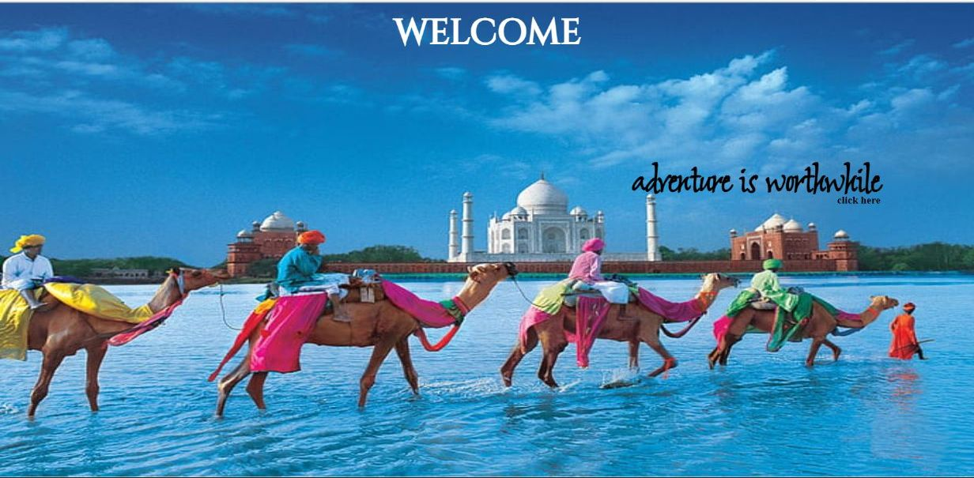

Screen-2:

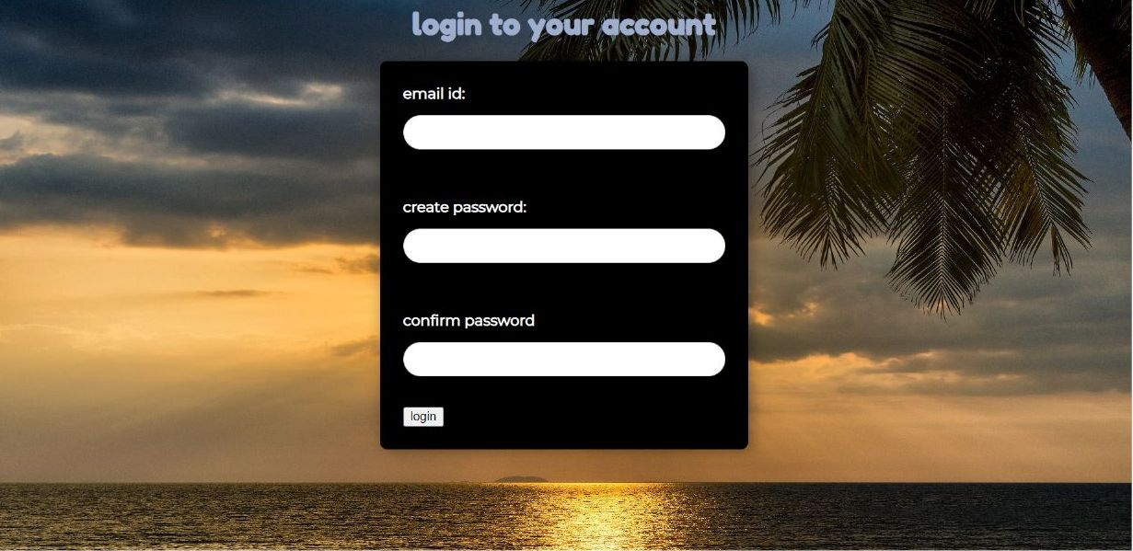

Screen-3:

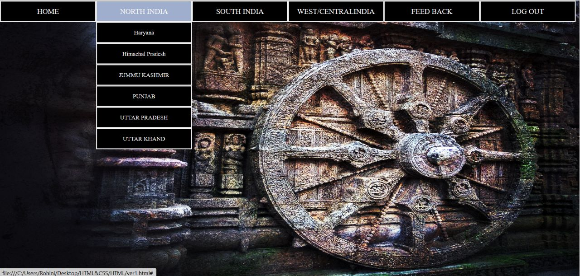

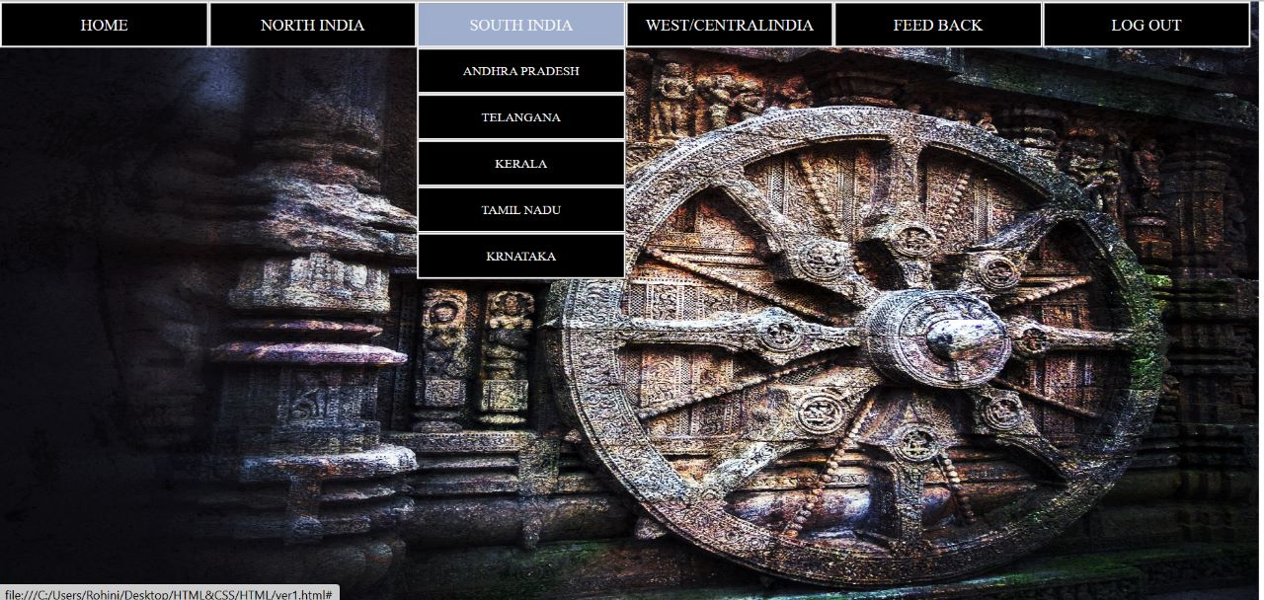

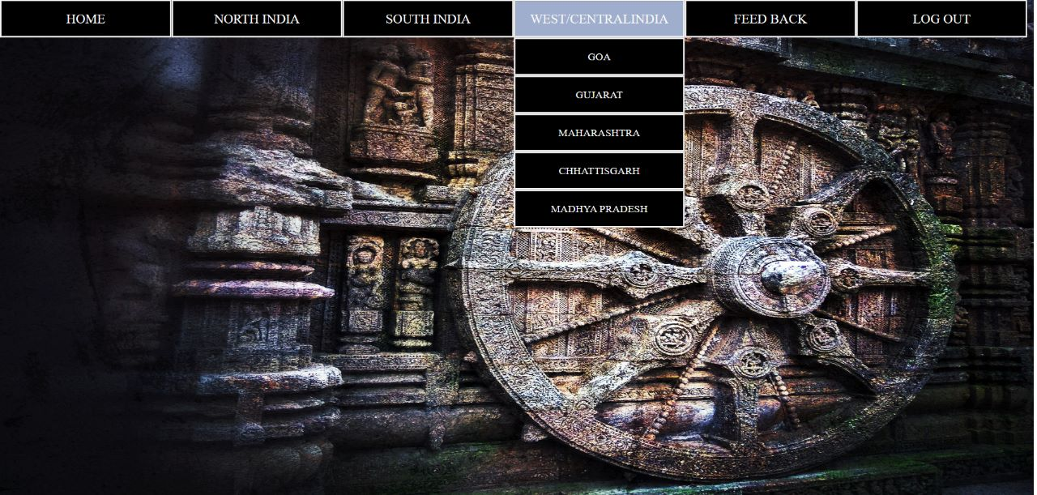

Screen-4:

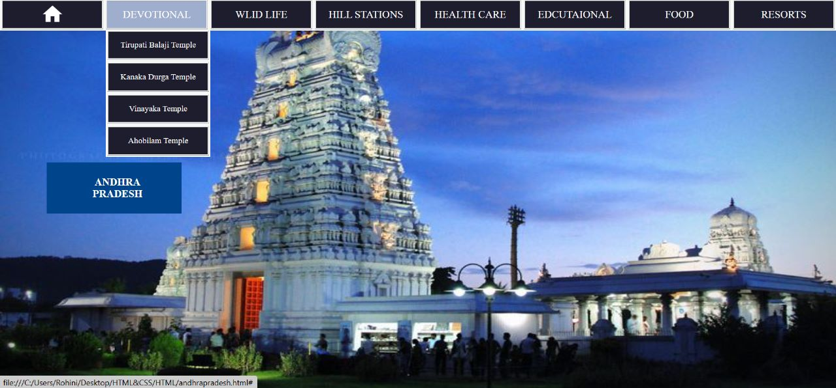

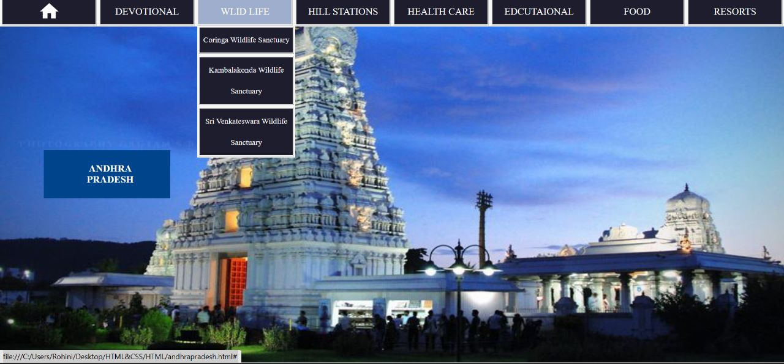

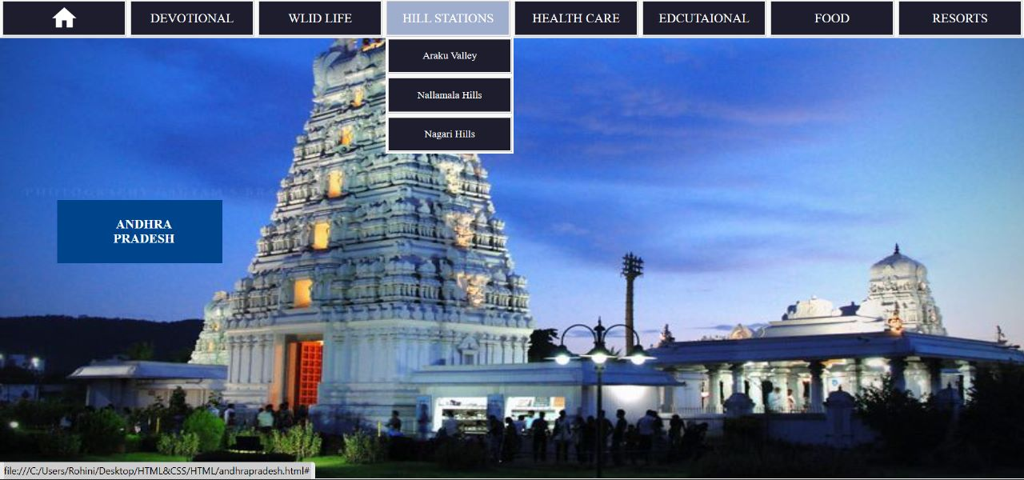

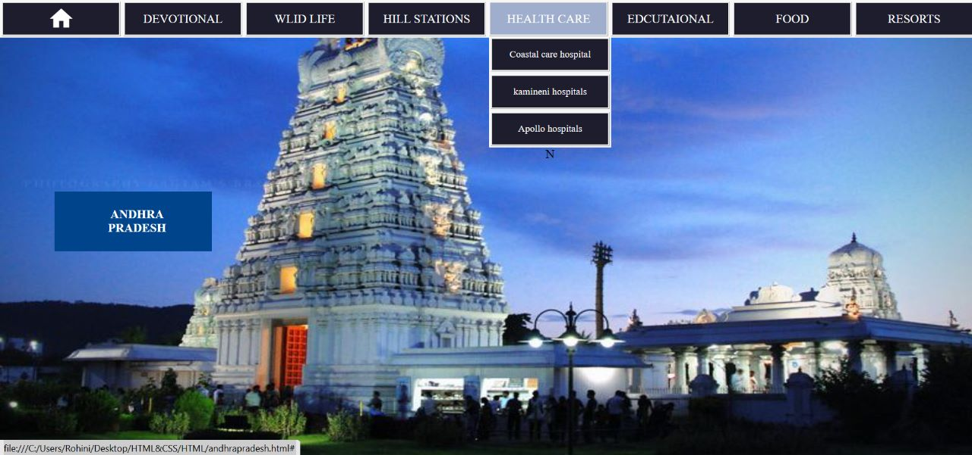

Screen-5:

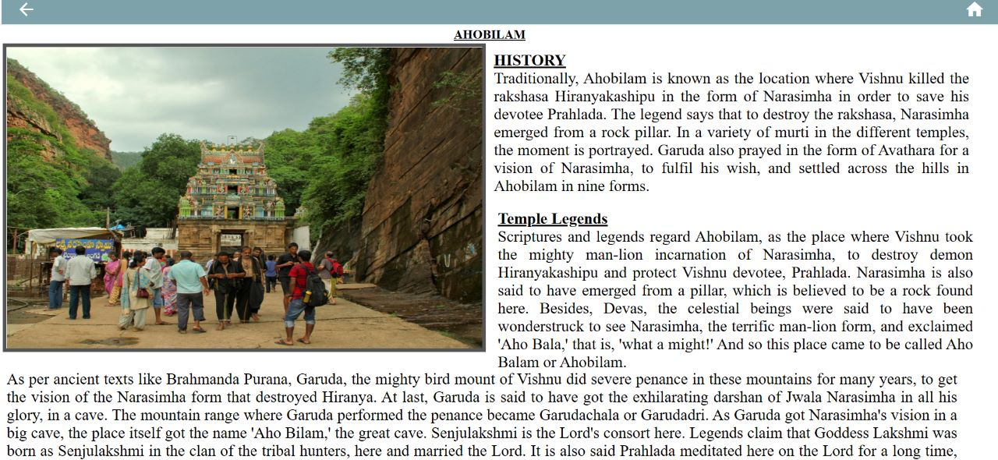

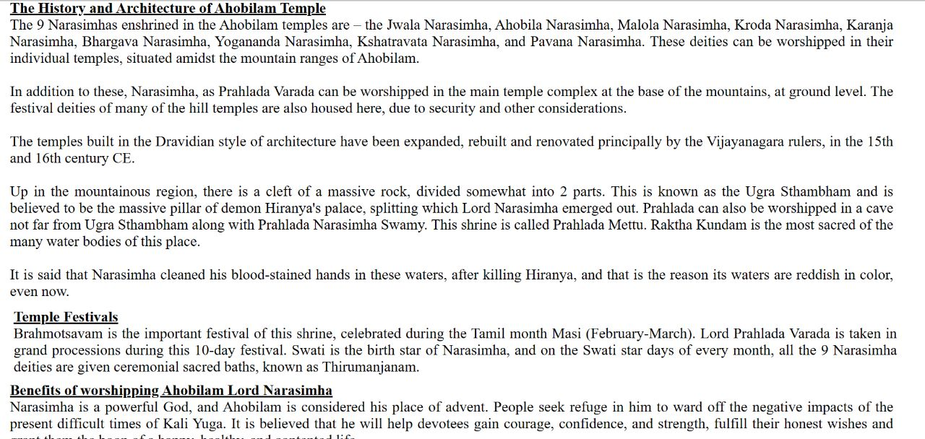

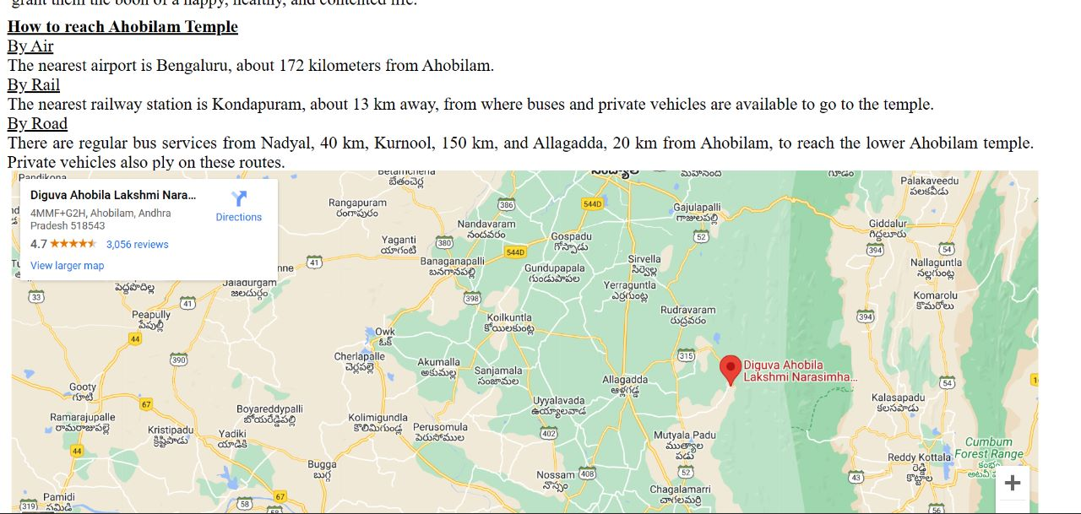

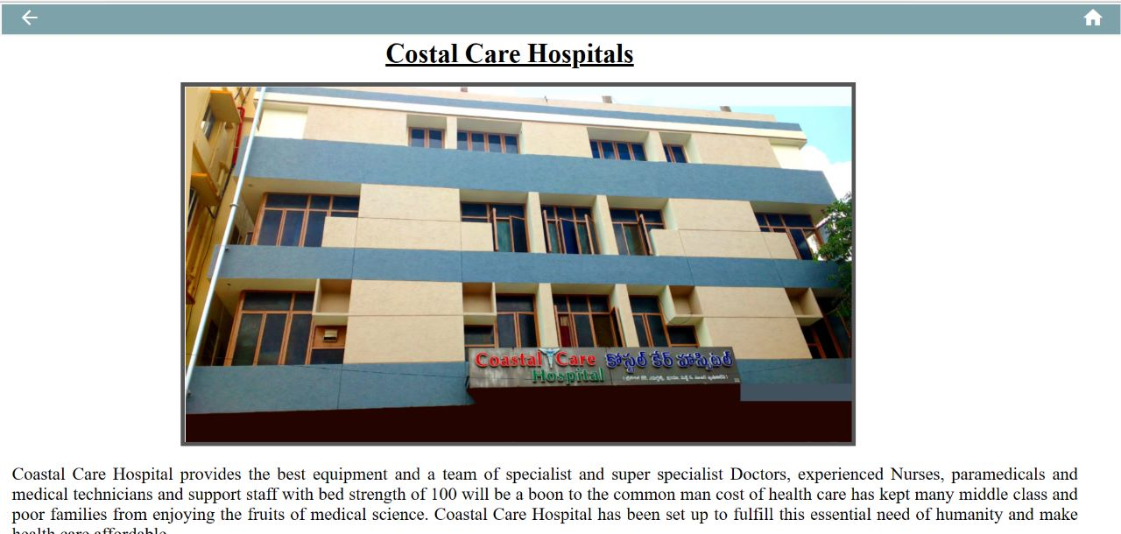

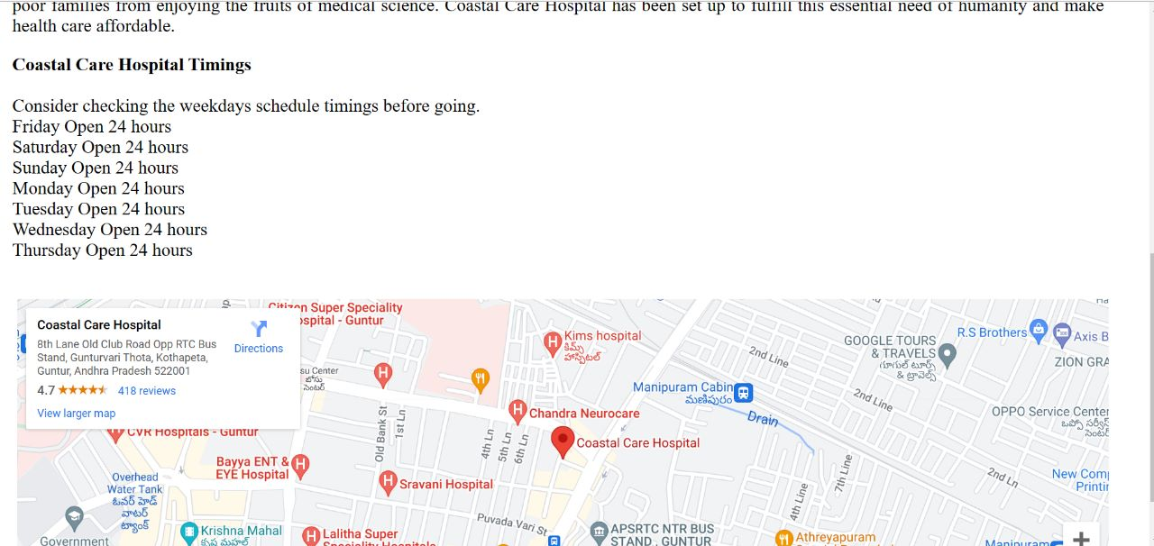

Screen-6:

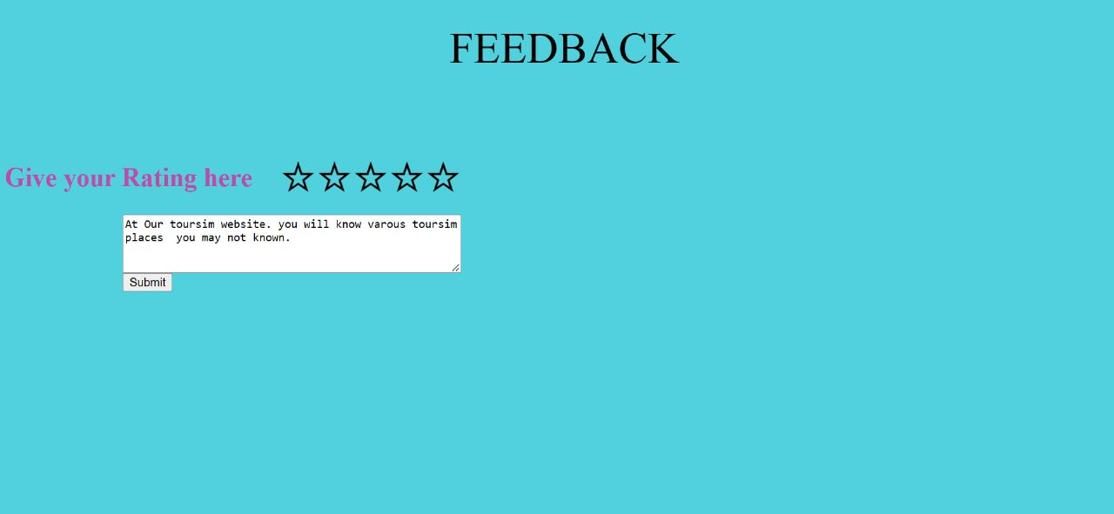

Screen-7:

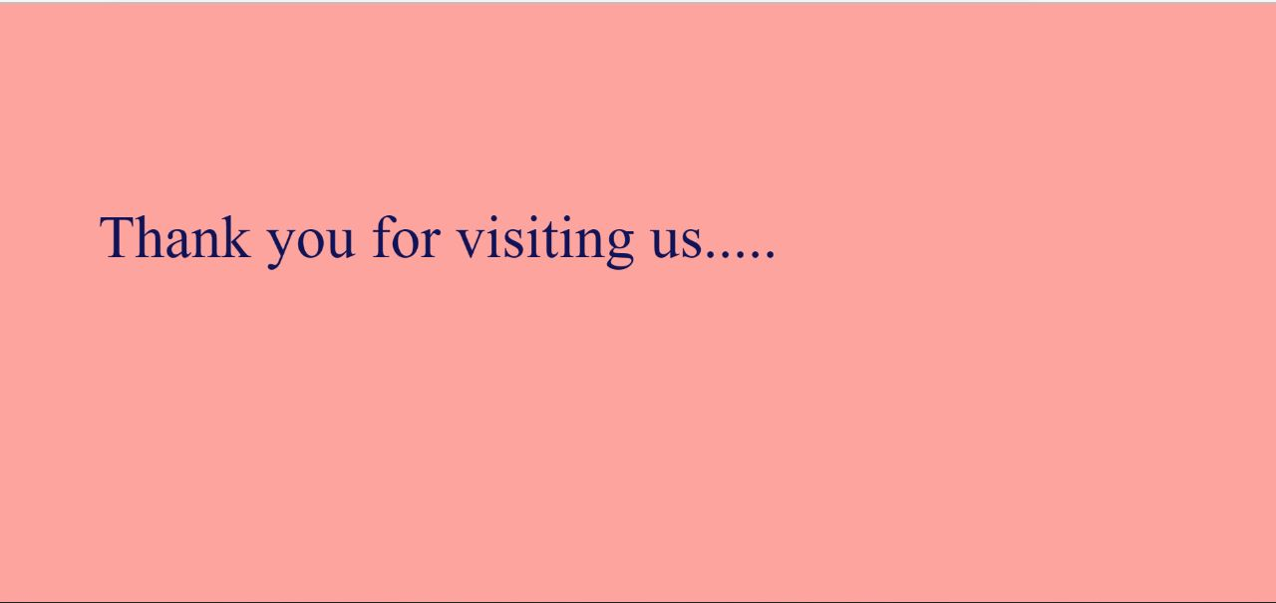

**CONCLUSION:**

Travellers continue to seek authentic experiences. The tools they use to research and book these experiences are constantly changing due to innovations in technology. Destinations are also challenged by limited financial resources and strong competition for tourist dollars from other iconic and even lesser known locations. The personalization of travel suggests that independent travel will have a stronger presence than group travel, however, we must always consider the type of traveler.

The travel services sector is being forced to innovate at a startling rate.

In the aspect of tourism, internet and web technologies have made more readily available information on tourist locations, accommodations, transportation, shopping, food, festivals, and other attractions, thus improving the whole tourism experiences.

Our website helps decide about places they want to visit and also allows the user of the system access all the details about their destination location and its’s surroundings.